REAL-TIME RESEARCH PROJECT ABSTRACT (A2)
TITLE OF THE PROJECT: ONLINE EXAM RESULT MANAGEMENT SYSTEM
Roll number | Student name | Ph.no | Email id
24891A6601 | A.SAI SREE | 6301621088 | saisreereddyavula@gmail.com
24891A6631 | K.HARSHITH | 9110549930 | harshithsaru2801@gmail.com
24891A6602 | B.V V S D S SANDEEP | 8698985666 | bacchusandeep5@gmail.com
24891A6647 | P.ABHISHIKTH | 8074271670 | abhipuppala9848@gmail.com
GUIDE NAME: Mr. K GOPI
ABSTRACT
The Online Exam Result Management System is a web-based application designed to manage, process, and publish examination results efficiently. This system replaces the traditional manual method of result preparation, which is time-consuming and error-prone. It allows administrators to enter, store, update, and publish student results securely in a centralized database.
The Online Exam Result Management System is a computerized web-based application developed to manage examination results in an efficient, accurate, and secure manner. In the traditional manual system, exam results are prepared and maintained using paper records or spreadsheets, which is a time-consuming process and may lead to errors, data loss, and difficulty in result retrieval. This system overcomes these problems by automating the entire result management process.
The main objective of this system is to simplify the process of storing, processing, and publishing examination results. It allows administrators to maintain student details, subject information, and marks in a centralized database. Teachers or authorized staff can enter marks securely, and the system automatically calculates total marks, percentages, grades, and pass or fail status based on predefined evaluation rules. This reduces manual calculations and ensures accuracy and consistency in results.
Students can easily access their results online using their registration number or login credentials. This provides transparency and saves time for both students and institutions. The system also supports result verification and approval by administrators before publishing, ensuring error-free and reliable results. Additionally, students can view, download, and print their mark sheets anytime and from anywhere.
The Online Exam Result Management System improves efficiency by reducing paperwork and administrative workload. It enhances data security by using authentication mechanisms and database backups to prevent unauthorized access and data loss. The system is user-friendly, reliable, and scalable, making it suitable for schools, colleges, and universities. Overall, this system modernizes the examination result process and provides a fast, accurate, and transparent solution for managing academic result.

BLOCK DIAGRAM / CIRCUIT DIAGRAM:

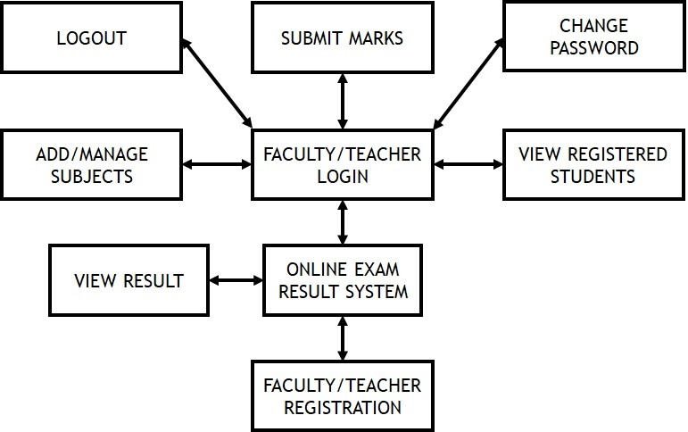

MR.K GOPI
GUIDE NAME & SIGNATURE HOD – CSE (AI&ML)

